Mortgage Payment Calculation - Full Answer
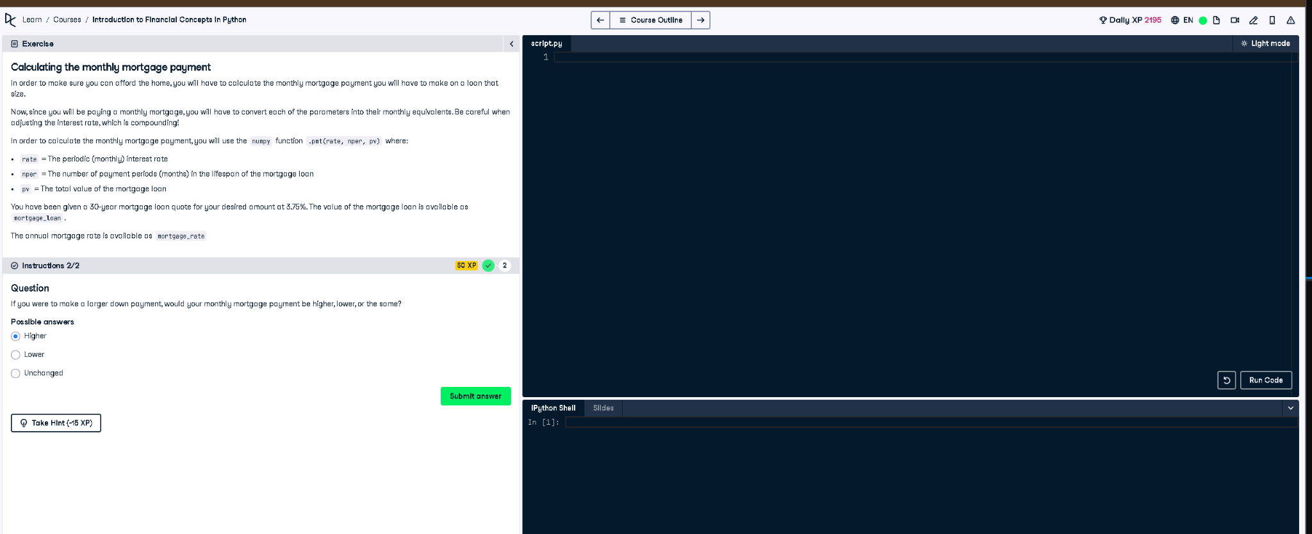

Full Code Answer:
import numpy as np
# Given data
mortgage_rate = 0.0375 # Annual interest rate
mortgage_loan = 300000 # Example total value of mortgage loan
years = 30 # Mortgage term in years
# Convert annual interest rate to monthly rate
rate = mortgage_rate / 12
# Total number of monthly payments
nper = years * 12
# Present value (loan amount)
pv = -mortgage_loan # Negative because it's an outgoing payment
# Calculate monthly payment
monthly_payment = np.pmt(rate, nper, pv)
print(f"Monthly Mortgage Payment: ${monthly_payment:.2f}")

Question:
If you were to make a larger down payment, would your monthly mortgage payment be higher, lower, or the same?

20-word Explanation (Question):
A larger down payment reduces the remaining principal balance, which decreases the required monthly mortgage payment over time.

Answer:
Lower

20-word Explanation (Answer):
A larger initial payment means borrowing less money, directly reducing monthly mortgage payments due to a smaller loan balance.

